**OUTPUTS**:

**1] CMD PROMPT COMMAND TO RUN THE CODE: (python app.py)**

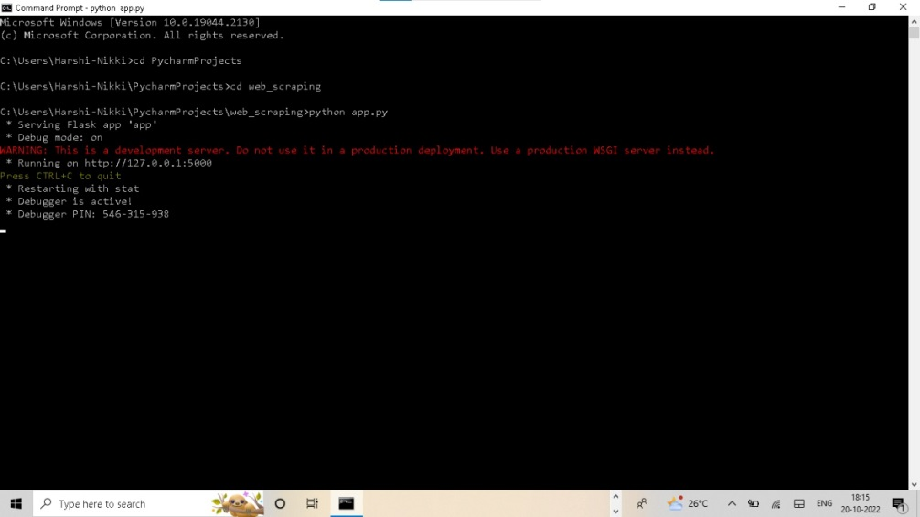

**2]WEBSITE AFTER ENTERING THE URL :** [**http://127.0.0.1:5000/**](http://127.0.0.1:5000/)

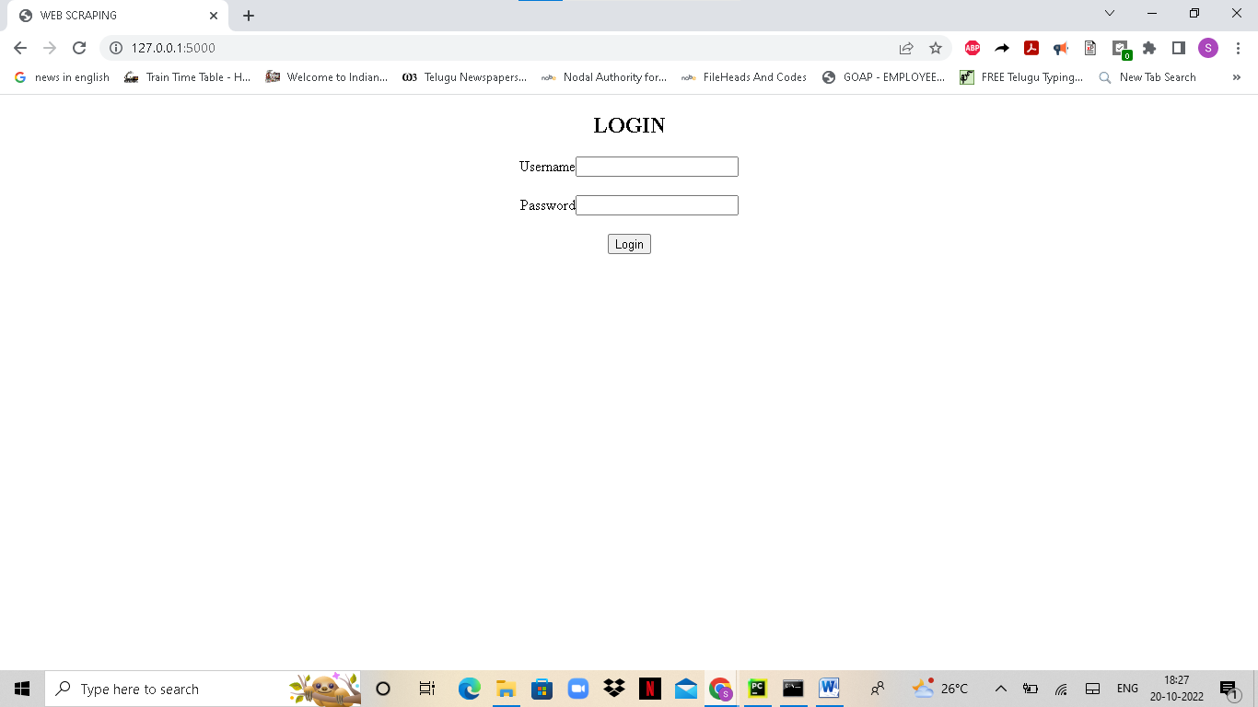

**3] LOGGING IN WITH WRONG CREDENTIALS: 12345, 12345**

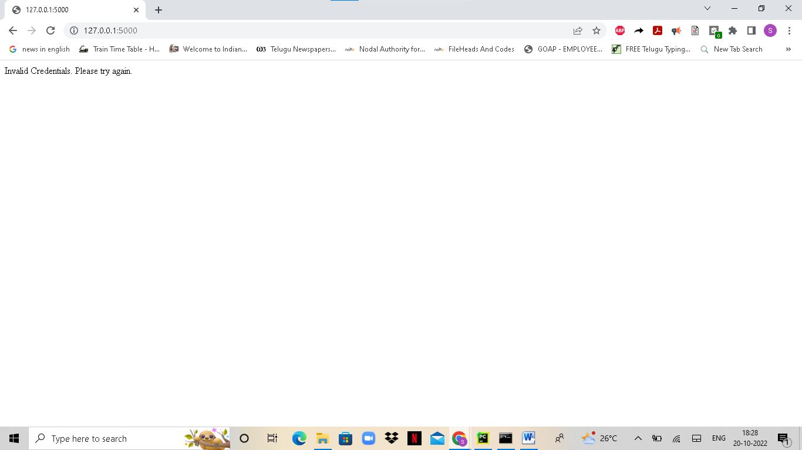

**4] LOGGING IN WITH CORRECT CREDENTIALS: admin, admin 🡪 HOME PAGE i.e. States page**

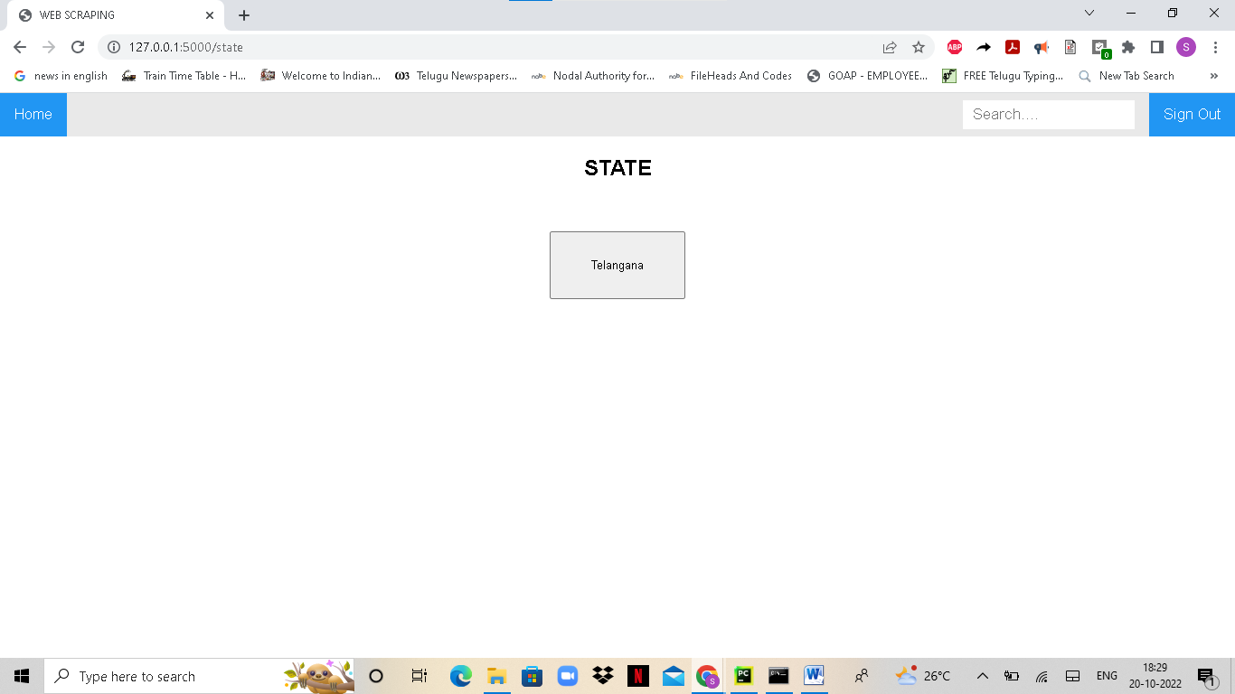

**5] CLICKING ON TELANGANA OR WE CAN ALSO TYPE “Telangana” IN SEARCH BAR WHICH GIVES SAME RESULT**

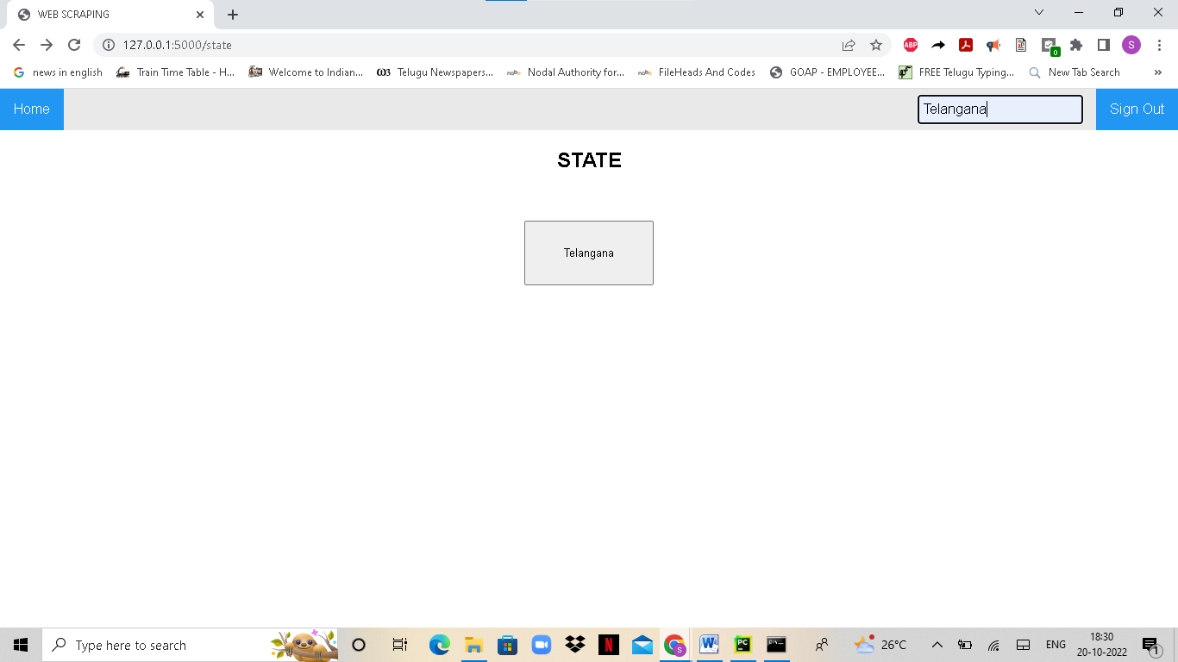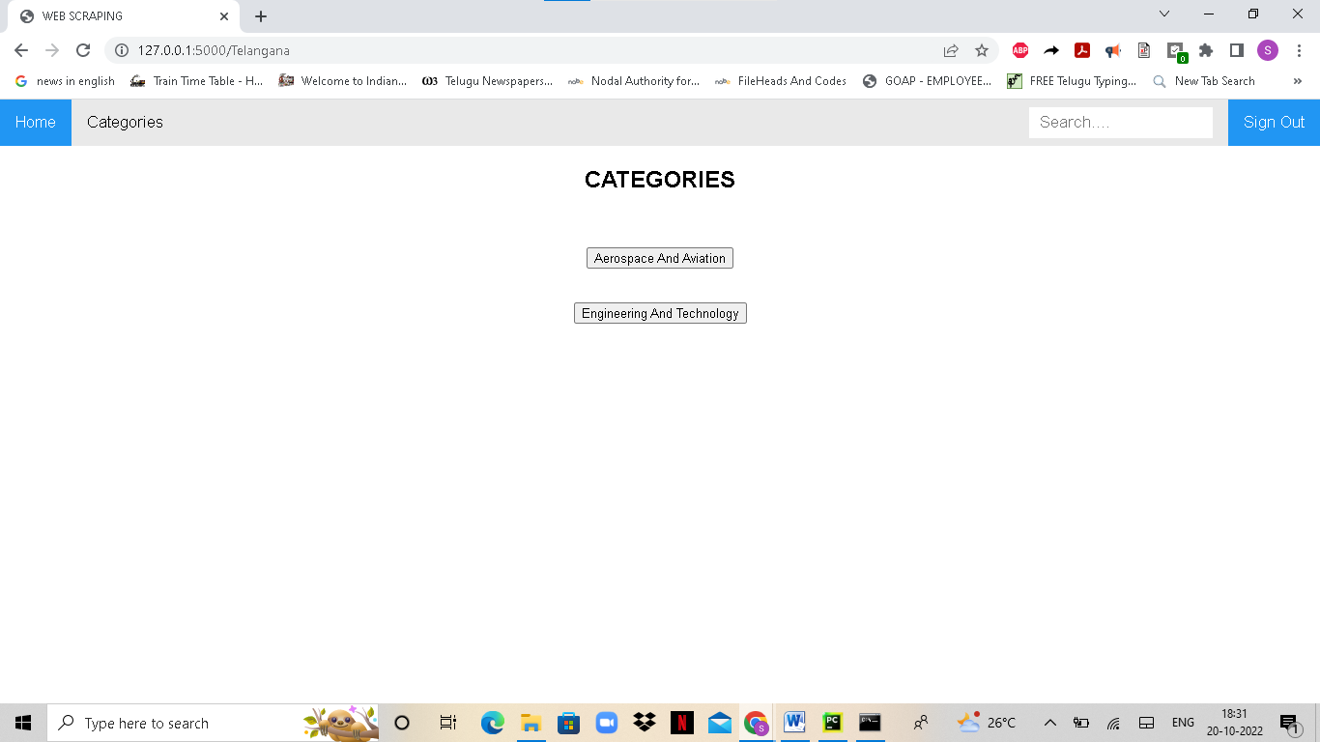

----🡪|

|

|

|

|

|

|

🡨---|

**6] CHOOSING A CATEGORY**

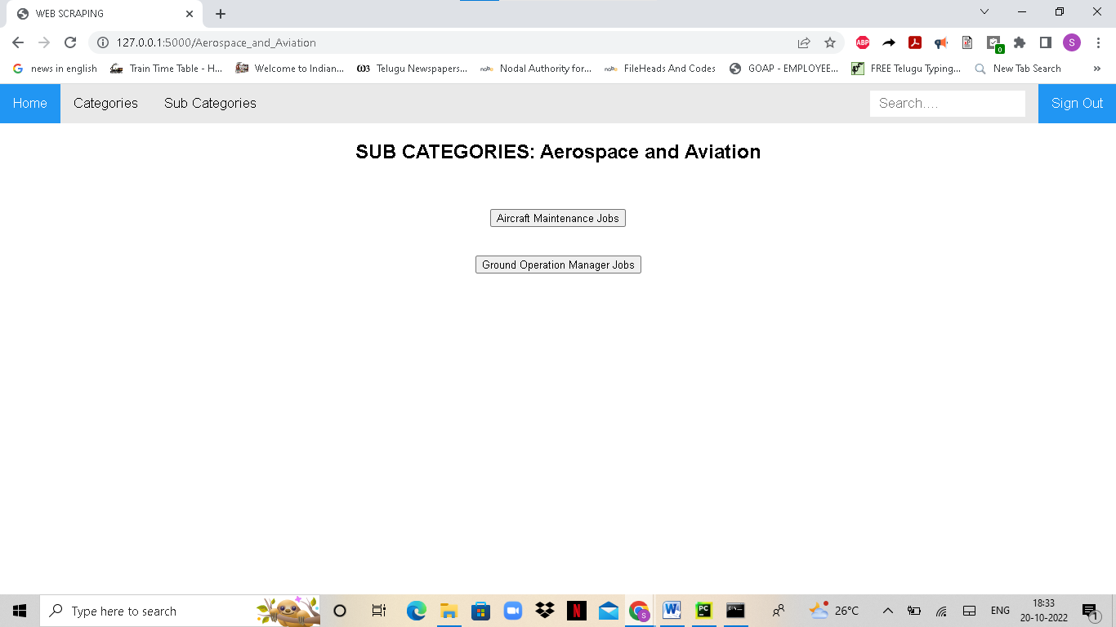

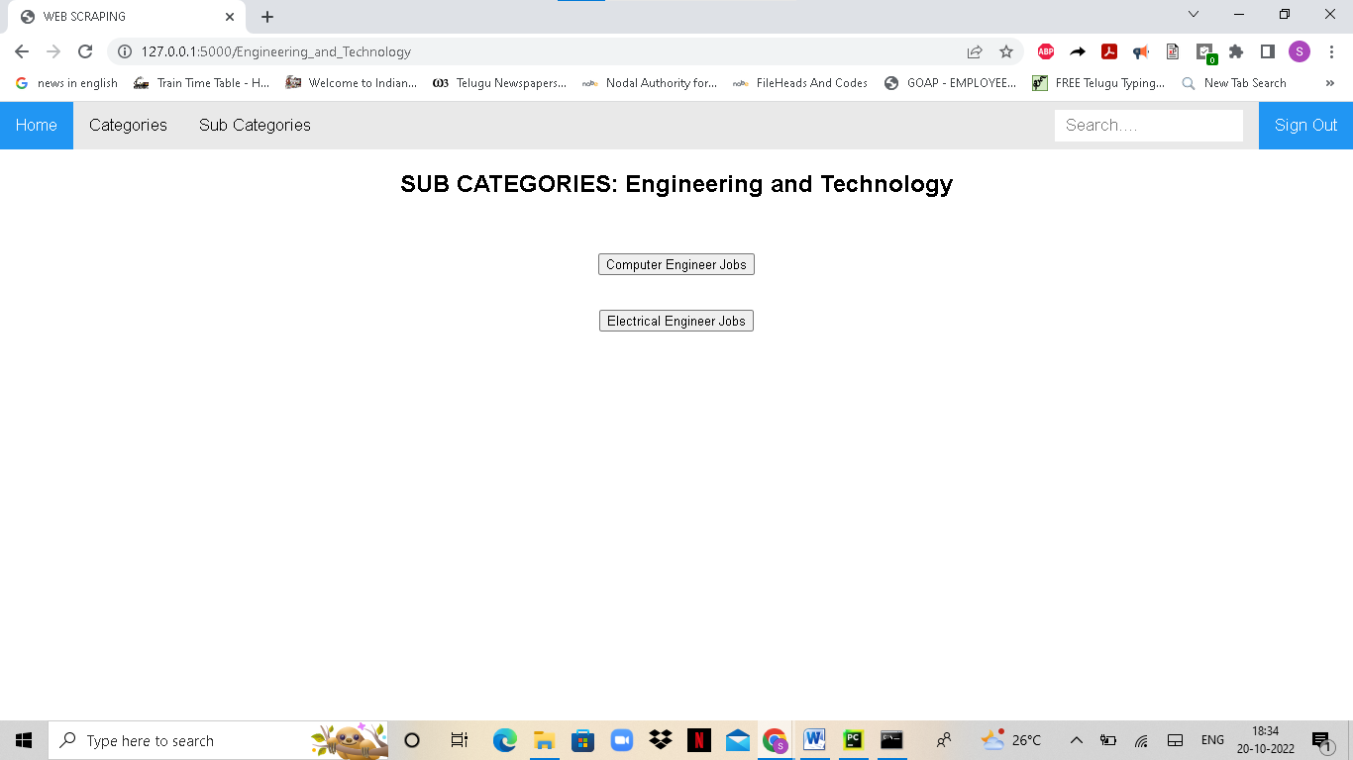

**6] CHOOSING A SUB CATEGORY WHICH WILL DISPLAY THE JOBS DETAILS AND COMPANY DETAILS**

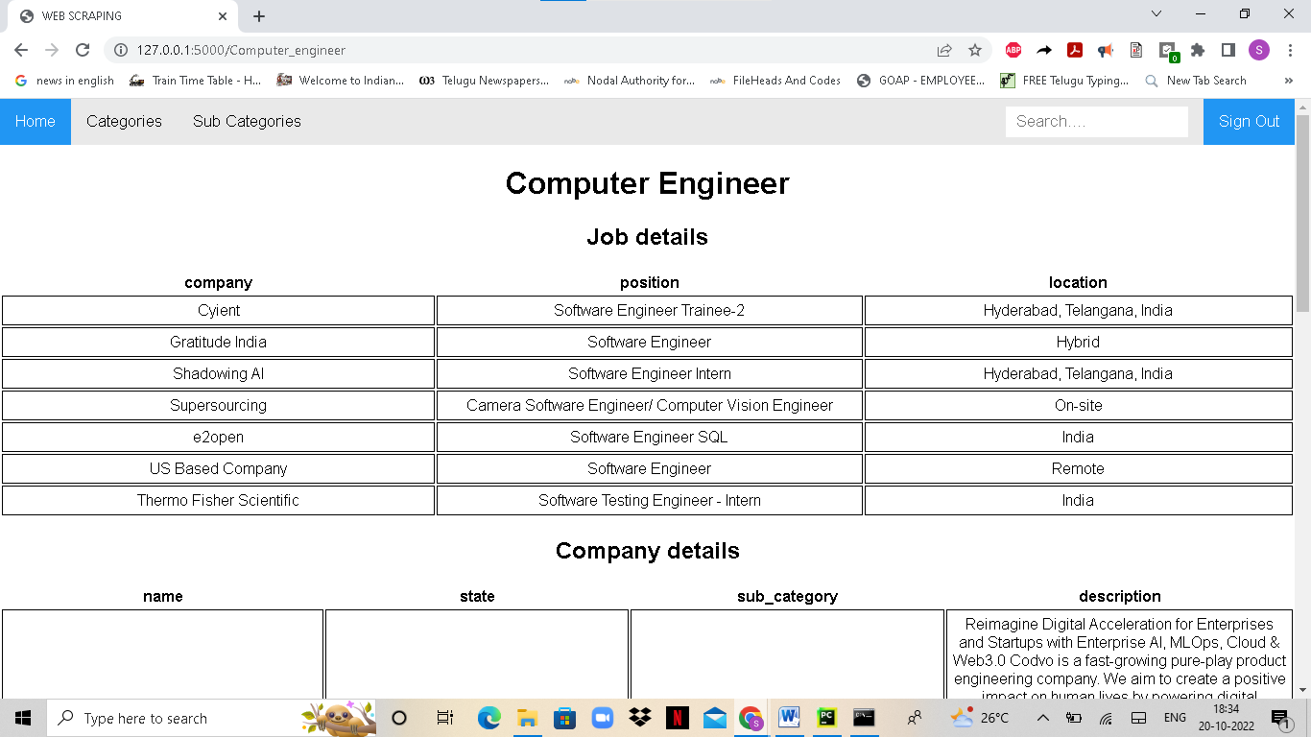

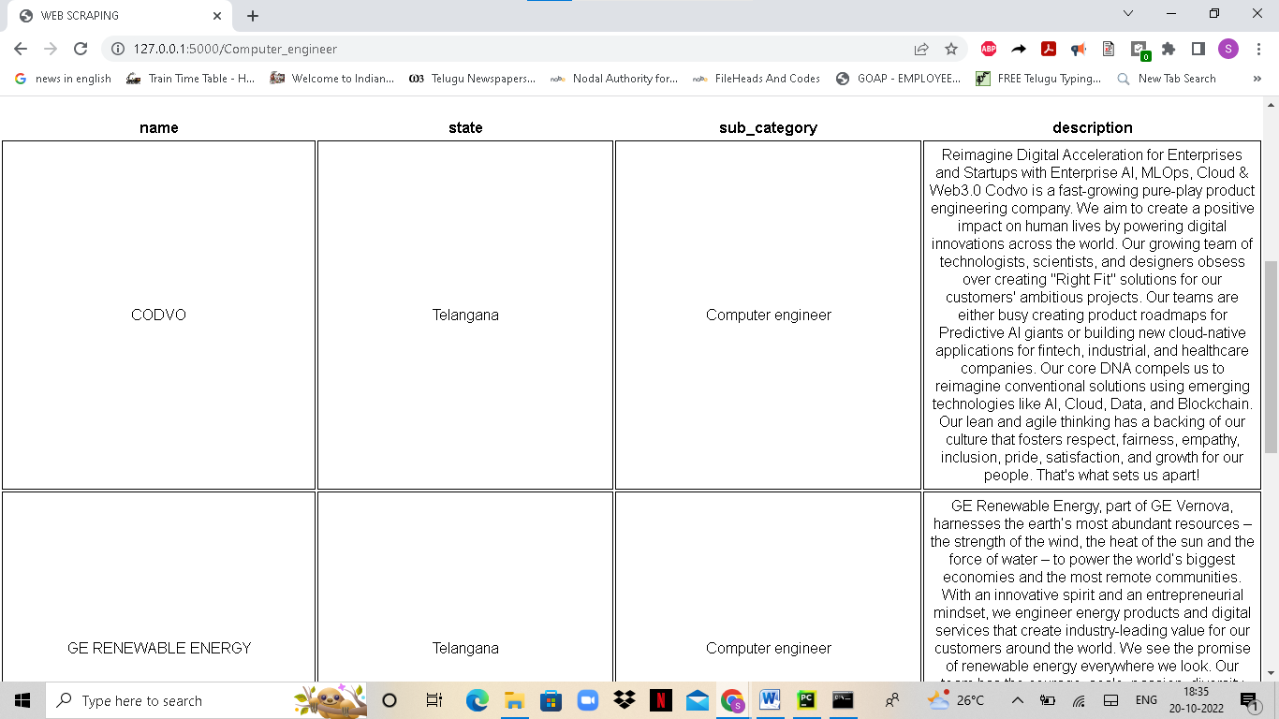

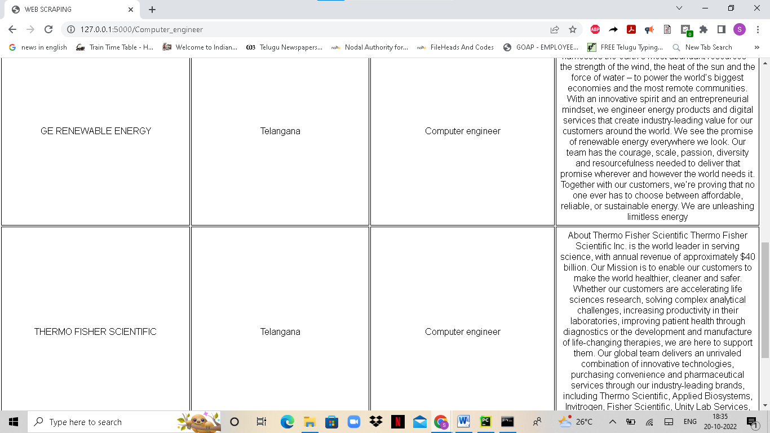

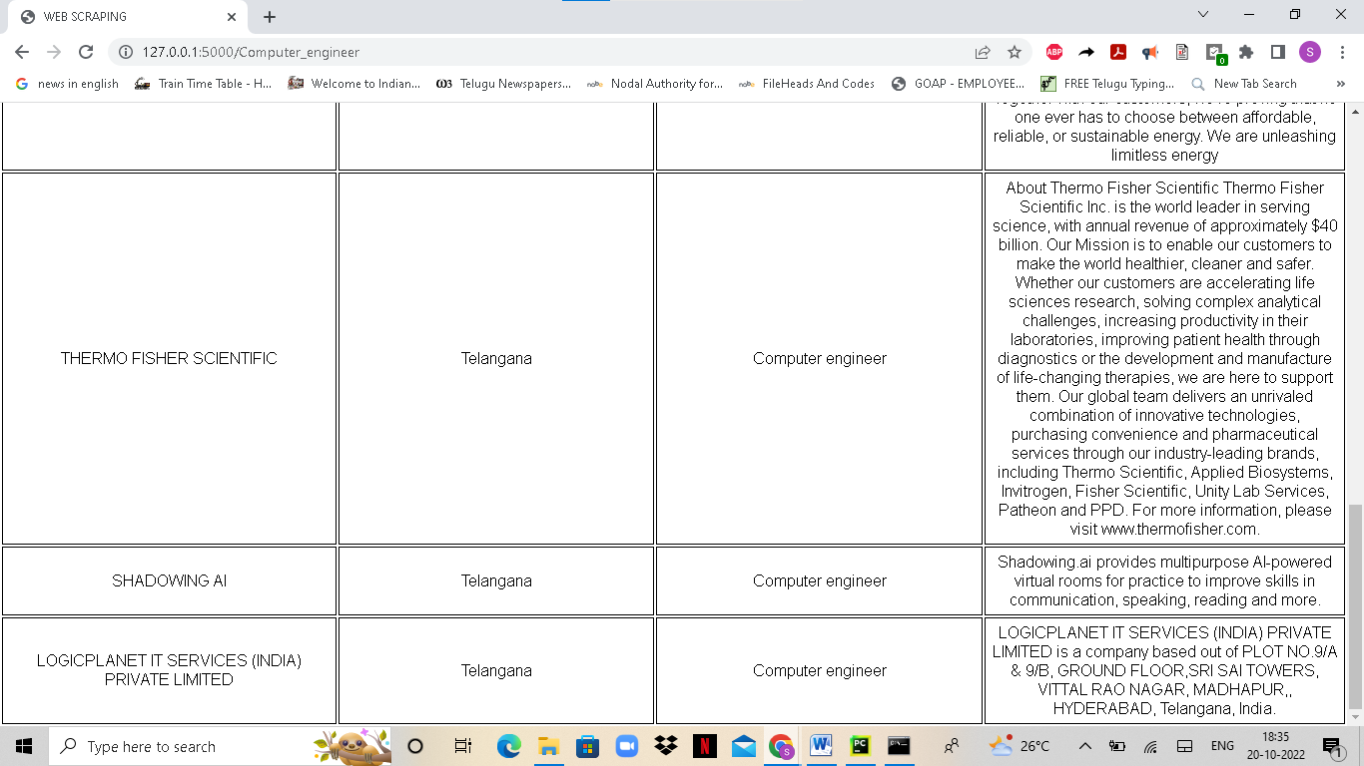

**IT DISPLAYS LIKE THIS FOR COMPUTER ENGINEER. FOR OTHER JOBS LETS JUST SEE THE START**

